**2D Physical World Report** – F07 Group7

Members:

Ang Jing Yuen Andre (1003308), Cao Bing Quan (1003881), Dionetta Young (1003735), Lan XiaoJin (1003773), Tim Yap Ming En (1003495)

1) Introduction

Waiting for a thermometer to read the temperature of an object is often long and inconvenient. This is because the thermometer must be at thermal equilibrium with the object to obtain an accurate reading and is dependent on thermometer heat capacity and heat transfer rate. To overcome this challenge, our group aims to create a better world by design, where cumbersome temperature waiting times can be greatly minimised without compromising the accuracy of the readings. By implementing concepts on linear regression, heat transfer modes and heat capacity, we aim to create a program that applies machine learning and statistical analysis to read data from a DS18B20 temperature sensor in a water bath and predict its temperature such that it is within +- 1.5 ℃ of commercial thermometer reading in a time span of less than 30 seconds. Real-time results will be displayed on our custom Kivy GUI to offer user-friendly interface. We expect our solution to provide the user with fast and accurately predicted temperatures within the range of 10℃ to 60℃.

2) Methods

Our setup consists of a 1L water bath in an insulated Styrofoam container, one DS18B20 temperature sensor, a laboratory thermometer, a Raspberry Pi and a SmartPiTouch for Kivy GUI display.

Assuming no work done by or on the temperature sensor,

|  |  |  |
| --- | --- | --- |
|  |  | (1) |

Based on equation (1) (Refer to Appendix), it allows us to linearise the initial equation such that it is a linear equation with the temperature of the water bath, Tw , as the y-axis values, the average initial gradient of the temperature of the temperature sensor against time,, as the x-axis values, as the gradient and , the initial sensor temperature before placing it into the water bath, or the ambient temperature, as the y-intercept.

Firstly, we need to obtain values for and . So, we collected multiple sets of data of how the reading of the temperature sensor changes in a fixed-temperature water bath with respect to time. We set the sensor to read the temperature every 1 second, and the range of the water bath temperature to be from 10°C to 60°C. Each test will be run for 20 seconds, giving 20 sets of data points.

A laboratory thermometer is placed in the water bath to measure the actual temperature of the water bath and ensure that the water bath is at the range of temperatures being tested.

From the data collected, Tw is obtained from the reading by the laboratory thermometer and is obtained by finding the average rate of change of the initial temperature of the sensor.

For the 20 data points, we find the initial gradient of a specific point n by applying for each and t. Then, we obtain the average rate of change of the initial temperature of the sensor by summing up the initial gradients for all 20 data points and dividing it by 20. (Fig.1,3,5,7,9,11)

By varying the temperature of the water bath by 5°C, we obtained the training data sets for the linear relationship between Tw and , with Tw ranging from 10°C to 60°C. (Fig.1,3,5,7,9,11)

Since the gradient of this linear model in equation (1) is , which is also independent of temperature, we can find it by plotting the graph of equation (1). (Fig.14.)

To ensure the reliability of the data we collected, we implemented some measures.

Firstly, measurements were only taken after the temperature of the thermometer was relatively invariant to ensure the temperature of the water bath is relatively constant throughout the water so as to provide more accurate and reliable readings.

Secondly, the inserting of the temperature sensor when the code was run was done promptly to ensure there is no delay in the reading. This is to minimize the error in the first few temperature readings as the accuracy of the statistical analysis of the data would be significantly flawed with the few erroneous initial readings and limit the ability of our model to predict the temperature accurately.

Thirdly, we ensured that T(error), or zero error of temperature sensor, is minimal. This is done by recording the temperature using the temperature sensor after temperature has stabilised and comparing it to the temperature measured using the laboratory thermometer, with range from 10°C to 60°C at 5°C intervals. It is found that the discrepancy between the stabilized water bath temperature from the temperature sensor and the temperature from the laboratory thermometer is negligible. This is important to obtain accurate and consistent data for our model.

3) Result and Discussion

From the pre-analysis, we assume that mechanical and electrical work is negligible. Hence, no work done by or on the temperature sensor and equation (1) holds.

Furthermore, we assume that 𝜏 is a constant that is independent of temperature. Based on extensive research, is a constant as it is the heat capacity of sensor[1] whilst is also a constant because it is the combined thermal resistance[2] (water to sensor). Since 𝜏 = and both and are constants, 𝜏 is also a constant and is not dependent on temperature. Subsequently, it is further justified in the graphs of sensor temperature readings against time elapsed (Fig.2,4,6,8,10,12) that yield the graph of equation (1) (Fig.14.), displaying a linear model with a relatively constant gradient 𝜏.

The model used to predict the temperature of the water bath works under the principle that the rate of change of the initial temperature of the sensor with respect to time varies linearly with the temperature of the water bath, with 𝜏 as the gradient of the linear model. Finding 𝜏 is useful in training of our model as it is the key component in generating the linear regression for the predicted temperature.

The calculated that we found from graph of equation (1) has the value of 12.83767982, and the initial sensor temperature has value of 24.57750592°C.

With the calculated and , a linear regression can be constructed to predict the water bath temperature with an . (Fig.14.)

This is done by setting the water bath temperature, Tw, as the dependent variable and the average initial gradient of the sensor as the independent variable. The latter will be computed by our program once the sensor is placed in the water bath. Once the algorithm receives sufficient data, it will apply machine learning to predict the water bath temperature accurately.

Based on our results, the predictions of the temperature of the water bath using the model proposed was relatively accurate. The predicted temperatures we obtained is within +- 1.5 ℃ of the laboratory thermometer reading temperature and the all the prediction times fall below 10s. (Table 1.) The largest temperature difference occurred at the highest temperature, with the other differences between the predicted temperatures and the actual temperature being .

4) Conclusion

In conclusion, our objective of predicting the actual temperature of the water bath accurately in the range 10℃ to 60℃ within the shortest time possible is achieved as our results (Table 1) yield predicted temperatures with an accuracy of +-1.5℃ of commercial thermometer reading and are predicted within 10 seconds. We also believe that 𝜏 is a significant component in modelling the linear regression in our DW part due to its crucial part in determining the value of the predicted temperature.

However, there was a noticed decrease in accuracy as the temperature increased, especially as it approached the upper-bound of 60°C. A trend started to emerge that only temperatures approximately around Tw ≤20℃ and 30℃≤ Tw ≤45℃ gave accurate results of <1℃. To tackle this problem, further experiments with more training datasets could be conducted to improve on the model’s accuracy.

Another issue that we encountered is that the ambient temperature may not be constant at around 24.6°C, leading to a decrease in accuracy of the temperature predicted. For future implementation, we can improve on our program’s machine learning algorithm by implementing codes that instantiates the surrounding temperature of the sensor as the initial temperature of the sensor such that the linear model can be adjusted accordingly to predict the correct temperature.

**Appendix**

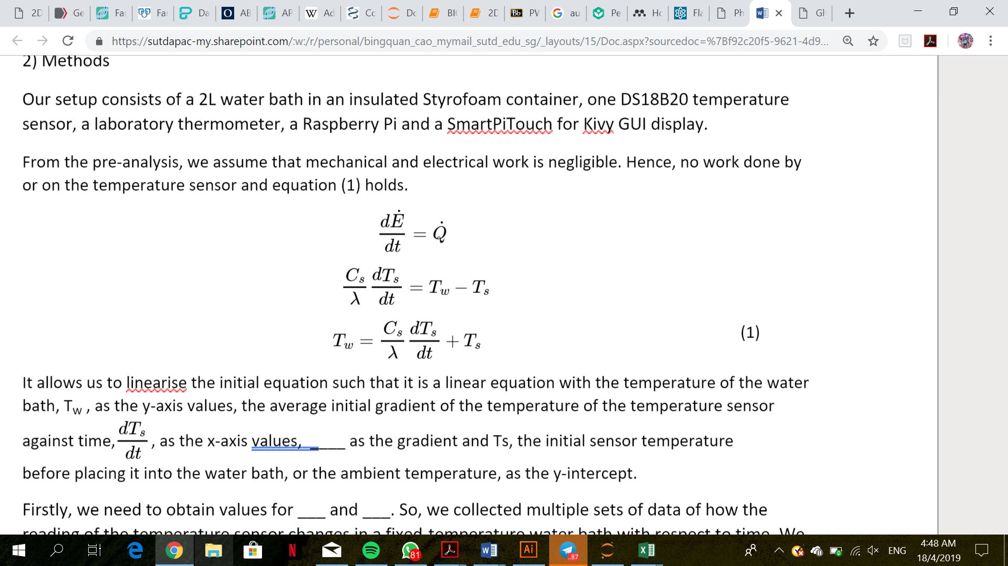

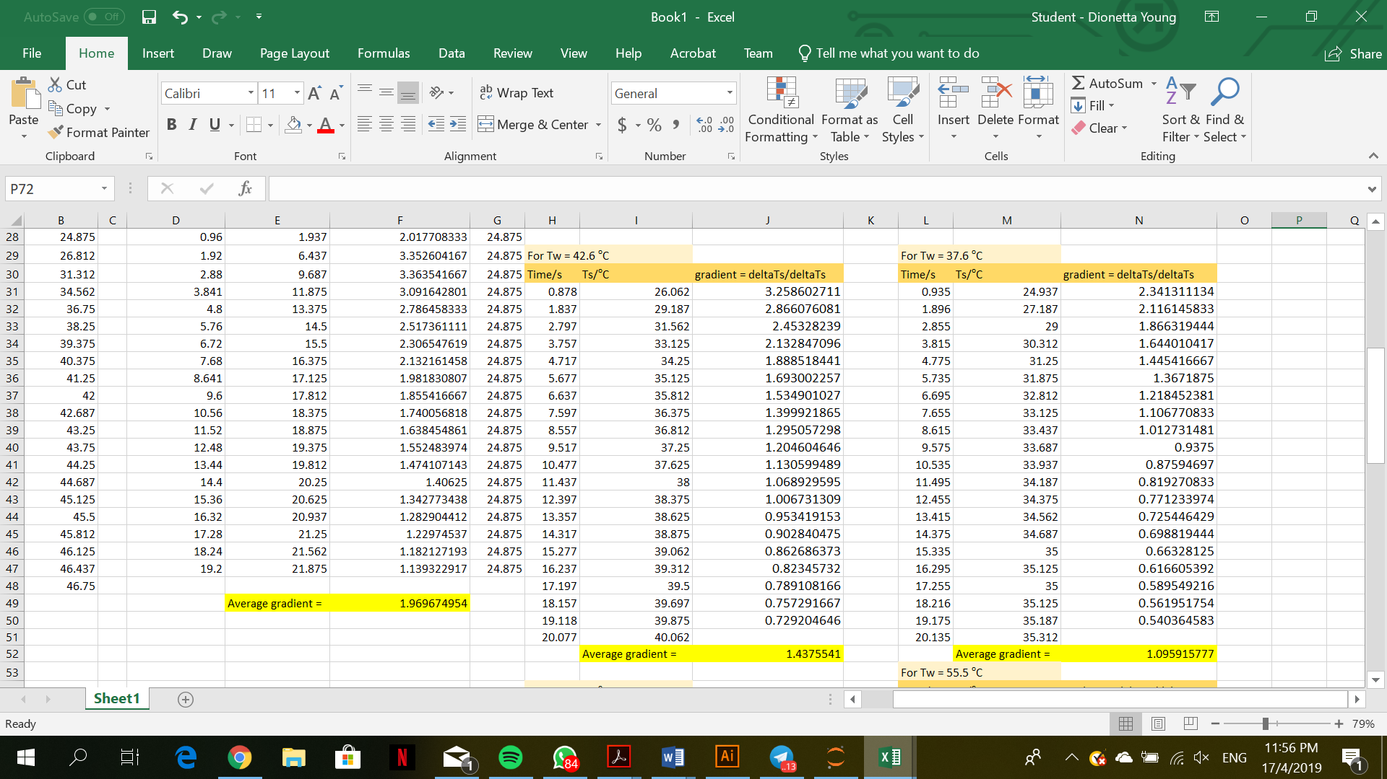

Fig. 1. Table of values for time/s, temperature of sensor (Ts)/oC, and gradient at each point for Tw = 37.6 oC

Fig. 2. Graph of temperature of sensor (Ts)/oC against time/s for Tw = 37.6 oC



Fig. 3. Table of values for time/s, temperature of sensor (Ts)/oC, and gradient at each point for Tw = 42.6 oC

Fig. 4. Graph of temperature of sensor (Ts)/oC against time/s for Tw = 42.6 oC

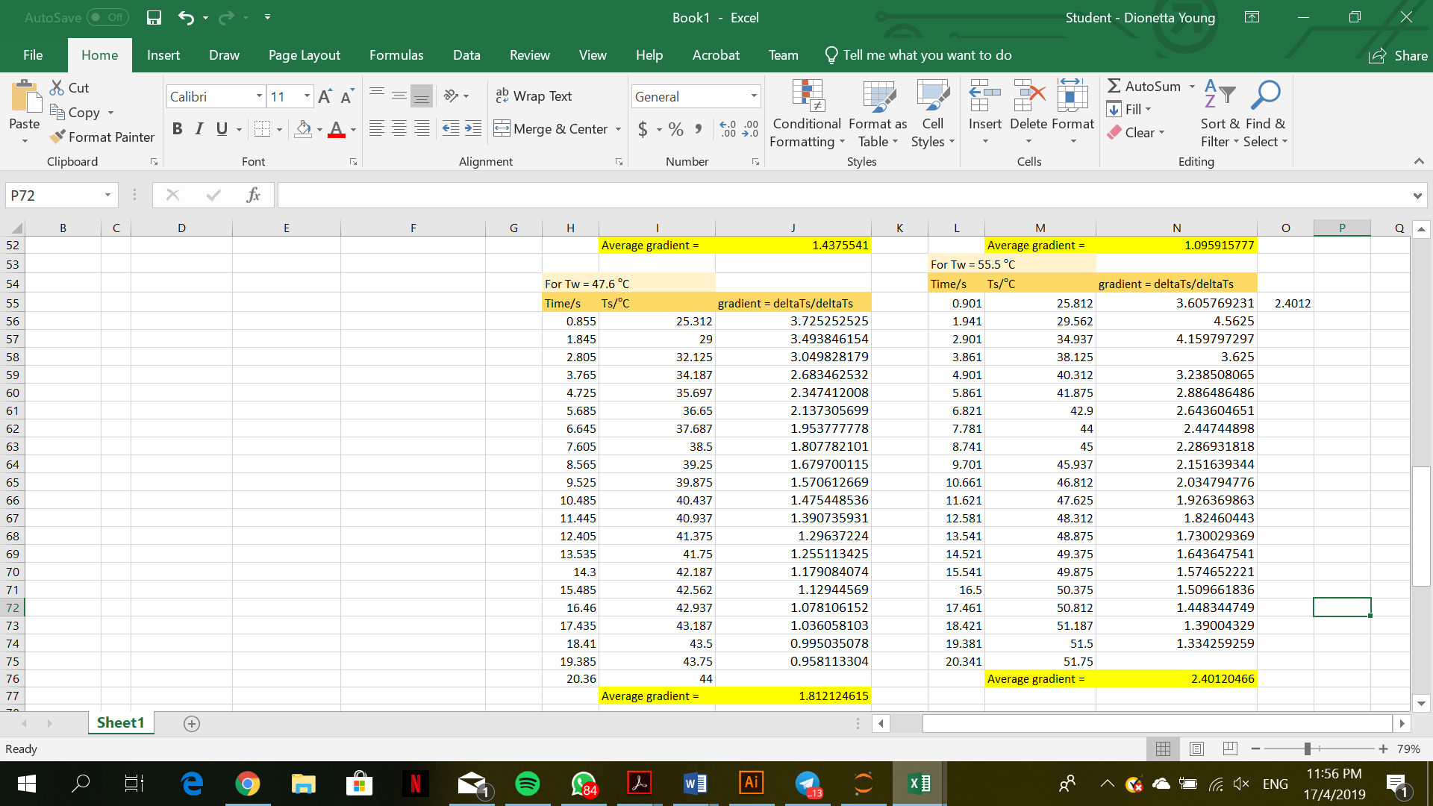

Fig. 5. Table of values for time/s, temperature of sensor (Ts)/oC, and gradient at each point for Tw = 47.6 oC

Fig. 6. Graph of temperature of sensor (Ts)/oC against time/s for Tw = 47.6 oC

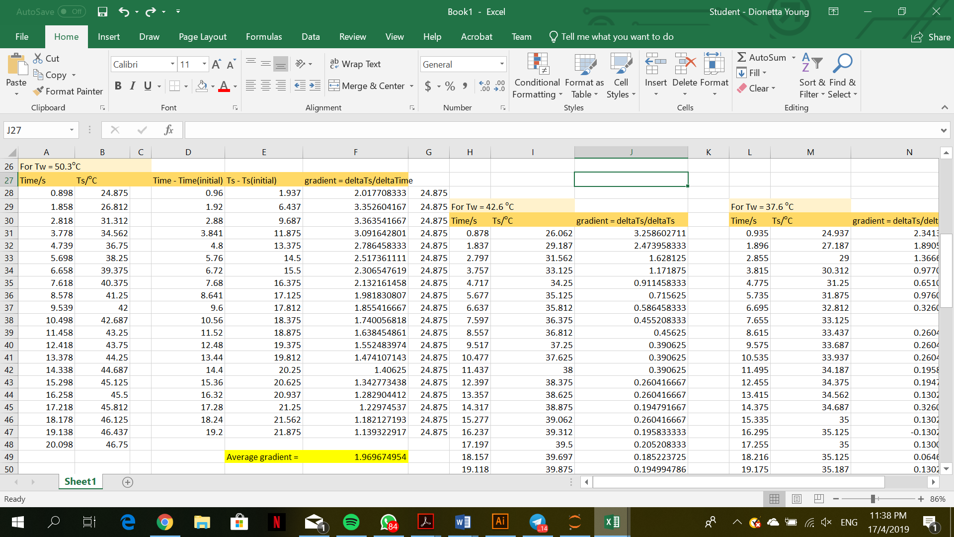

Fig. 7. Table of values for time/s, temperature of sensor (Ts)/oC, and gradient at each point for Tw = 50.3 oC

Fig. 8. Graph of temperature of sensor (Ts)/oC against time/s for Tw = 50.3 oC

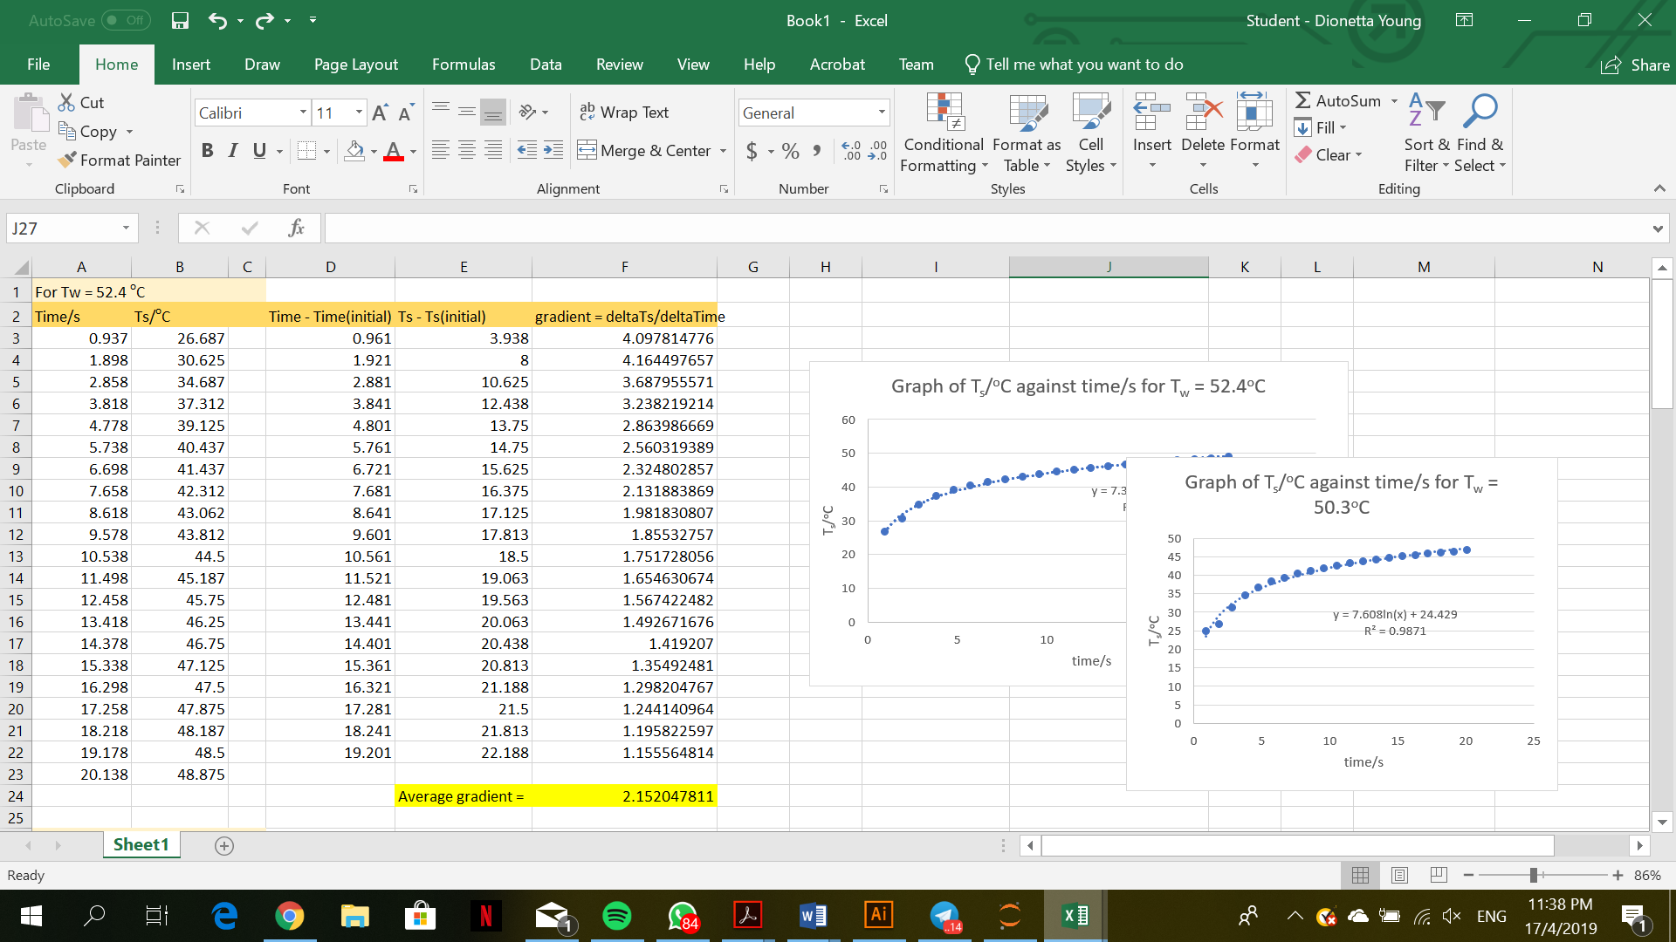

Fig. 9. Table of values for time/s, temperature of sensor (Ts)/oC, and gradient at each point for Tw = 52.4 oC

Fig. 10. Graph of temperature of sensor (Ts)/oC against time/s for Tw = 52.4 oC



Fig. 11. Table of values for time/s, temperature of sensor (Ts)/oC, and gradient at each point for Tw = 55.5 oC

Fig. 12. Graph of temperature of sensor (Ts)/oC against time/s for Tw = 55.5 oC

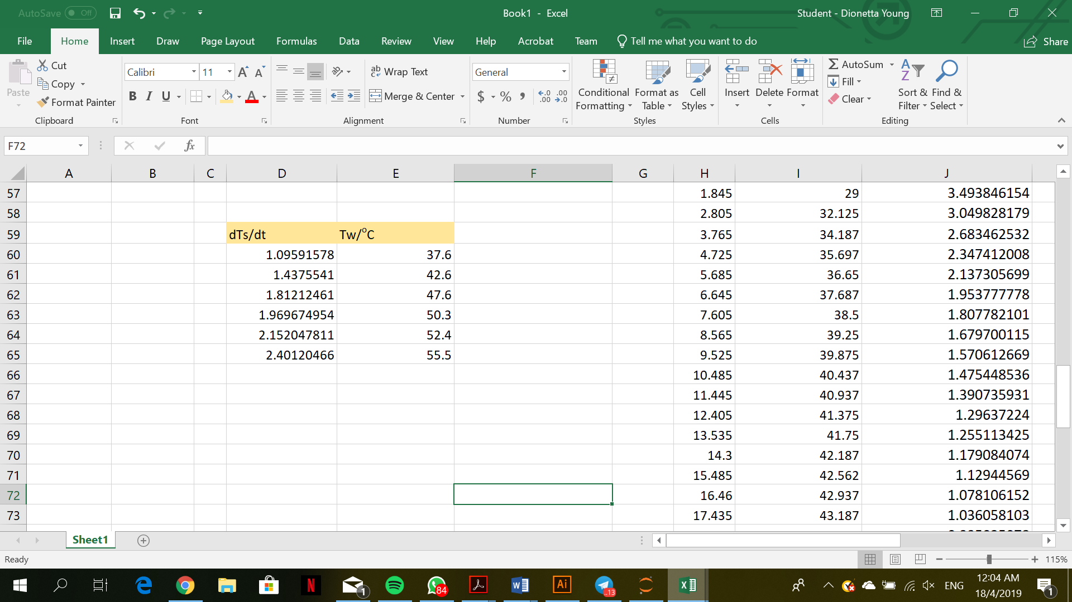

Fig. 13. Table of values for temperature of water bath (Tw)/oC, and average gradient of each time against Ts graphs/oC s-1 for each Tw values

Fig. 14. Graph of Tw/oC against (dTs/dt) / oC s-1 for each Tw values

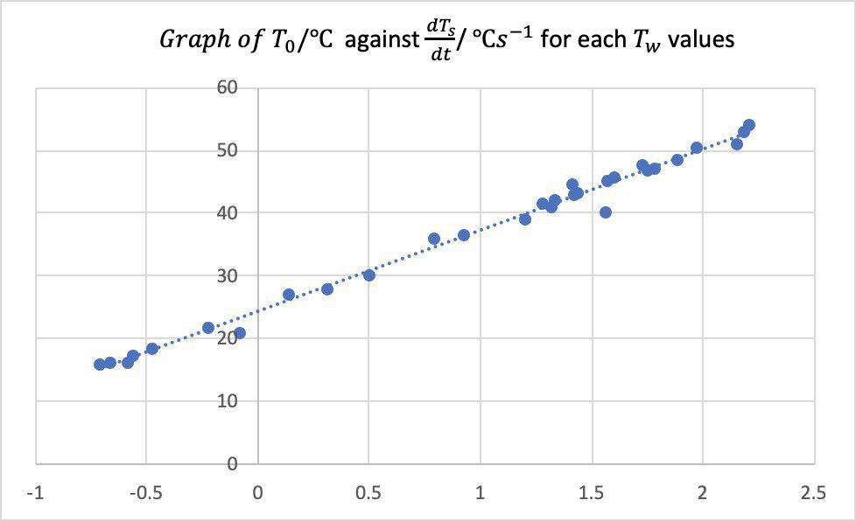

Fig. 15. Graph of T0/ oC against (dTs/dt) / oC s-1 for each Tw values.

|  |  |  |  |
| --- | --- | --- | --- |
| Water Bath Temperature/  ℃ | Predicted Temperature/  ℃ | Initial Temperature/  ℃ | Time Taken to Obtain the Predicted Temperature/s |
| 30.2 | 31.0 | 24.5 | 7.2 |
| 35.8 | 35.6 | 25.0 | 7.5 |
| 44.7 | 45.2 | 25.2 | 7.0 |
| 52.3 | 52.0 | 24.67 | 7.4 |
| 56.5 | 55.2 | 25.0 | 7.5 |

Table 1: Predictions of the temperature of the water bath with the RPi code and sensor.

1. Valencia, J. J., Quested, P. N. 2008. Thermophysical Properties. ASM International. Retrieved from <https://materialsdata.nist.gov/bitstream/handle/11115/166/Thermophysical%20Properties.pdf?sequence=3>
2. Parker , W. J., Jenkins, R. J., Butler, C. P. , Abbott, G. L. 11 June 2004. Flash Method of Determining Thermal Diffusivity, Heat Capacity, and Thermal Conductivity. USA. Retrieved from <https://aip.scitation.org/doi/pdf/10.1063/1.1728417?class=pdf>